Anthony Cunningham

Research Data Management

STAT 5810

2/2/2018

**Homework 1**

1) A.

|  |  |  |  |
| --- | --- | --- | --- |
| region | positive | _N_ | ERROR |
|  | . | 1 | 0 |
| Region 1 | 16.9% | 1 | 0 |
|  | . | 2 | 0 |
| Region 2 | 19.3% | 2 | 0 |

B.

|  |  |  |  |
| --- | --- | --- | --- |
| region | positive | _N_ | ERROR |
|  | . | 1 | 0 |
| Region 1 | 16.9% | 1 | 0 |
|  | . | 2 | 0 |
| Region3 | 23.1% | 2 | 0 |

2) A.

libname hw1 "H:\My SAS Files";

**data** hw1.stocks;

infile "H:\My SAS Files\stockprices.txt";

input stock $4. purDate mmddyy10. +**1** purPrice dollar5.1 +**1** numShares **3.** sellDate mmddyy10. +**1** sellPrice dollar5.1;

**run**;

**proc** **print** data=hw1.stocks;

**run**;

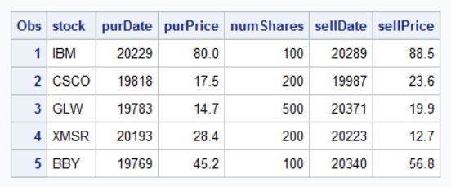

B.

**data** hw1.stocks;

infile "H:\My SAS Files\stockprices.txt";

input stock $4. purDate mmddyy10. +**1** purPrice dollar5.1 +**1** numShares **3.** sellDate mmddyy10. +**1** sellPrice dollar5.1;

totalPur=numShares*purPrice;

totalSell=numShares*sellPrice;

profit=totalSell - totalPur;

**run**;

**proc** **print** data=hw1.stocks;

**run**;

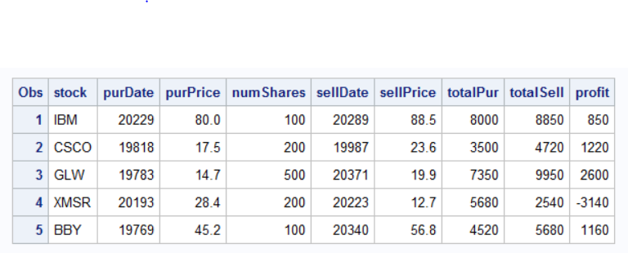

3)

(Dataset) 20 15

15 500

10 100

5 15

0 20

**data** hw1.infileOptions;

infile "H:\My SAS Files\hw1Q3.txt";

input x y **3.**;

**run**;

**proc** **print** data=hw1.infileOptions;

**run**;

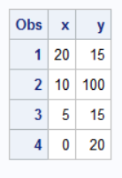

**data** hw1.infileOptions;

infile "H:\My SAS Files\hw1Q3.txt" missover;

input x y **3.**;

**run**;

**proc** **print** data=hw1.infileOptions;

**run**;

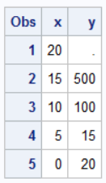

**data** hw1.infileOptions;

infile "H:\My SAS Files\hw1Q3.txt" truncover;

input x y **3.**;

**run**;

**proc** **print** data=hw1.infileOptions;

**run**;

